# 📝 To-Do List Web Application

A **clean, functional To-Do List Web App** built using **HTML, CSS, and Vanilla JavaScript** that allows users to **add, complete, and delete tasks seamlessly**, with **localStorage** ensuring your tasks remain even after refreshing or closing the browser.

## 🚀 Features

* Add new tasks easily
* Mark tasks as completed with a strikethrough
* Delete tasks when no longer needed
* Automatically saves tasks in localStorage
* Simple, clean, and responsive design

## 🛠️ Tech Stack

* HTML5
* CSS3
* JavaScript (Vanilla)

## 📥 Installation

1. Clone the repository:

git clone https://github.com/itzsaravanan/todoapplication.git

1. Navigate to the folder:

cd todoapplication

1. Open index.html in your browser to start using the app.

## 📸 Screenshots

### Create Task Interface

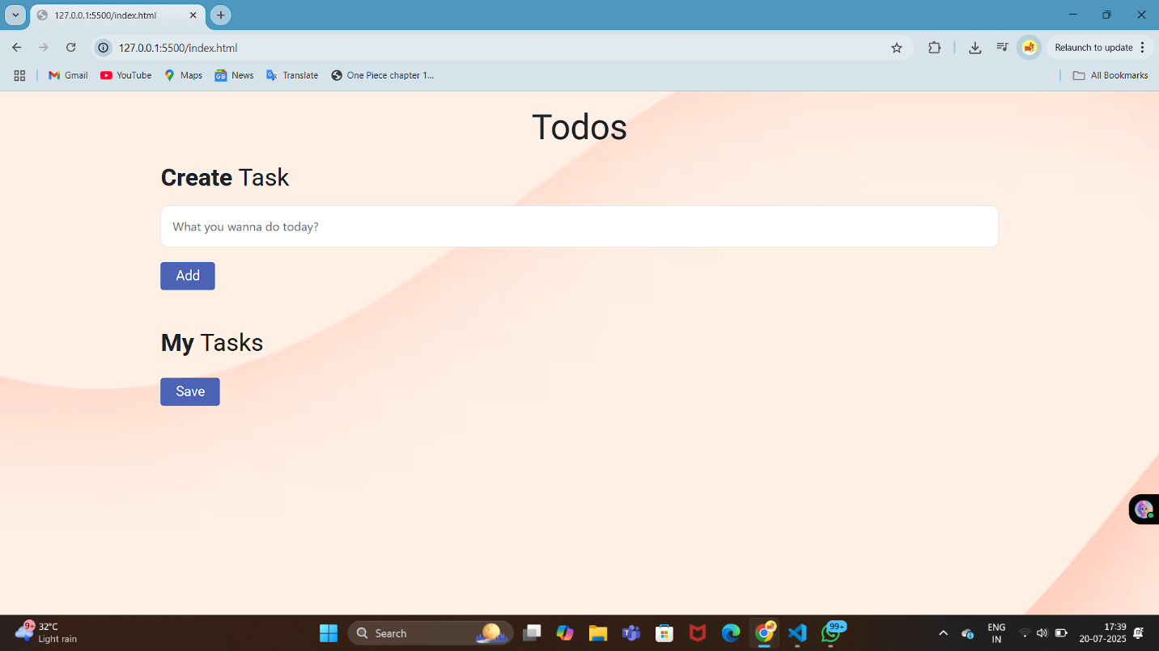

### Task List Display

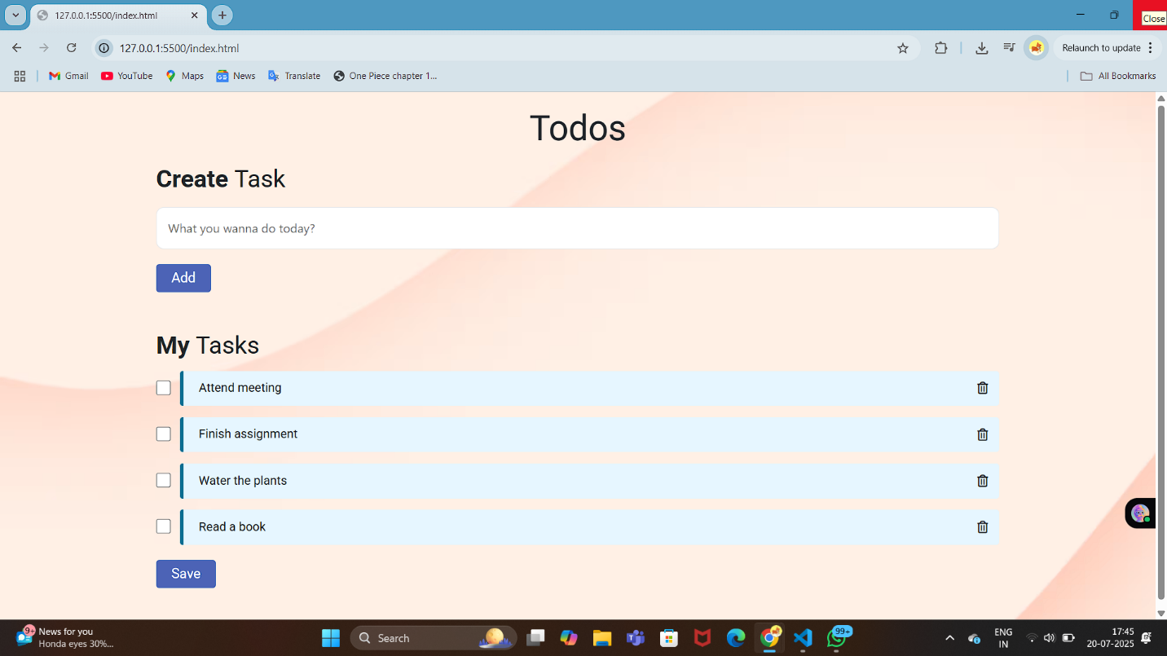

### Mark Tasks as Complete

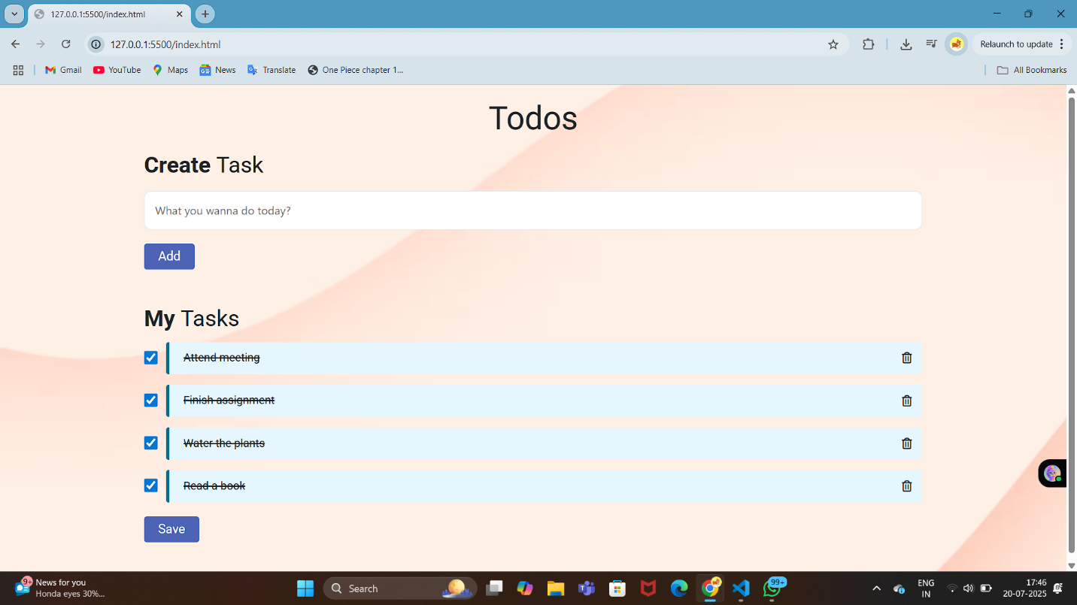

## ✨ Future Enhancements

* Edit existing tasks
* Dark/Light mode toggle
* Drag-and-drop reordering
* Deploy as a Progressive Web App (PWA)
* GitHub Pages live deployment

## 🤝 Contributions

Contributions and suggestions are welcome! Feel free to open an issue or submit a pull request to improve the project.

## 📜 License

This project is open-source under the **MIT License**.

**Developed with ❤️ by** [**Saravanan**](https://github.com/itzsaravanan)